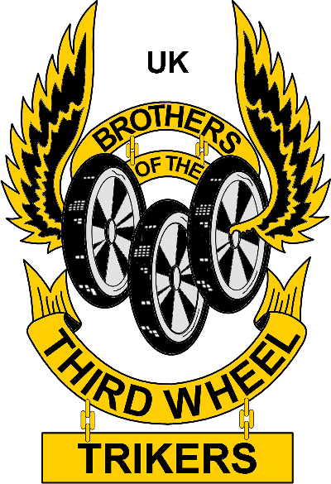
You Have Just Met
Name:
Phone:
E-mail:
A Brothers of the Third Wheel
International Association Member
A FAMILY OF TRIKERS
IE website www.btw-ie.com

You Have Just Met
Name:
Phone:
E-mail:
A Brothers of the Third Wheel
International Association Member
A FAMILY OF TRIKERS
IE website www.btw-ie.com

You Have Just Met
Name:
Phone:
E-mail:
A Brothers of the Third Wheel
International Association Member
A FAMILY OF TRIKERS
IE website www.btw-ie.com
You Have Just Met
Name:
Phone:
E-mail:
A Brothers of the Third Wheel
International Association Member
A FAMILY OF TRIKERS
IE website www.btw-ie.com

You Have Just Met
Name:
Phone:
E-mail:
A Brothers of the Third Wheel
International Association Member
A FAMILY OF TRIKERS
IE website www.btw-ie.com

You Have Just Met
Name:
Phone:
E-mail:
A Brothers of the Third Wheel
International Association Member
A FAMILY OF TRIKERS
IE website www.btw-ie.com

You Have Just Met
Name:
Phone:
E-mail:
A Brothers of the Third Wheel
International Association Member
A FAMILY OF TRIKERS
IE website www.btw-ie.com

You Have Just Met
Name:
Phone:
E-mail:
A Brothers of the Third Wheel
International Association Member
A FAMILY OF TRIKERS
IE website www.btw-ie.com

You Have Just Met
Name: Name:
Phone:
E-mail:
A Brothers of the Third Wheel
International Association Member
A FAMILY OF TRIKERS
IE website www.btw-ie.com

You Have Just Met
Name: Name:
Phone:
E-mail:
A Brothers of the Third Wheel
International Association Member
A FAMILY OF TRIKERS
UK website www.btw-uk.co.uk
You Have Just Met
Name:
Phone:
E-mail:
A Brothers of the Third Wheel
International Association Member
A FAMILY OF TRIKERS
IE website www.btw-ie.com

You Have Just Met
Name:
Phone:
E-mail:
A Brothers of the Third Wheel
International Association Member
A FAMILY OF TRIKERS
IE website www.btw-ie.com

